〓〓〓〓〓〓〓〓〓〓〓〓〓〓〓〓〓〓〓〓〓〓〓〓〓〓〓〓〓〓〓〓〓〓〓〓〓〓〓〓〓〓〓〓〓

Company Name | MEMS Corp. | Company Logo
Address | B7-308, KOPTI, 20-13 Cheomdanventure-soro 38beon-gil, Buk-gu, Gwangju, Republic of Korea | 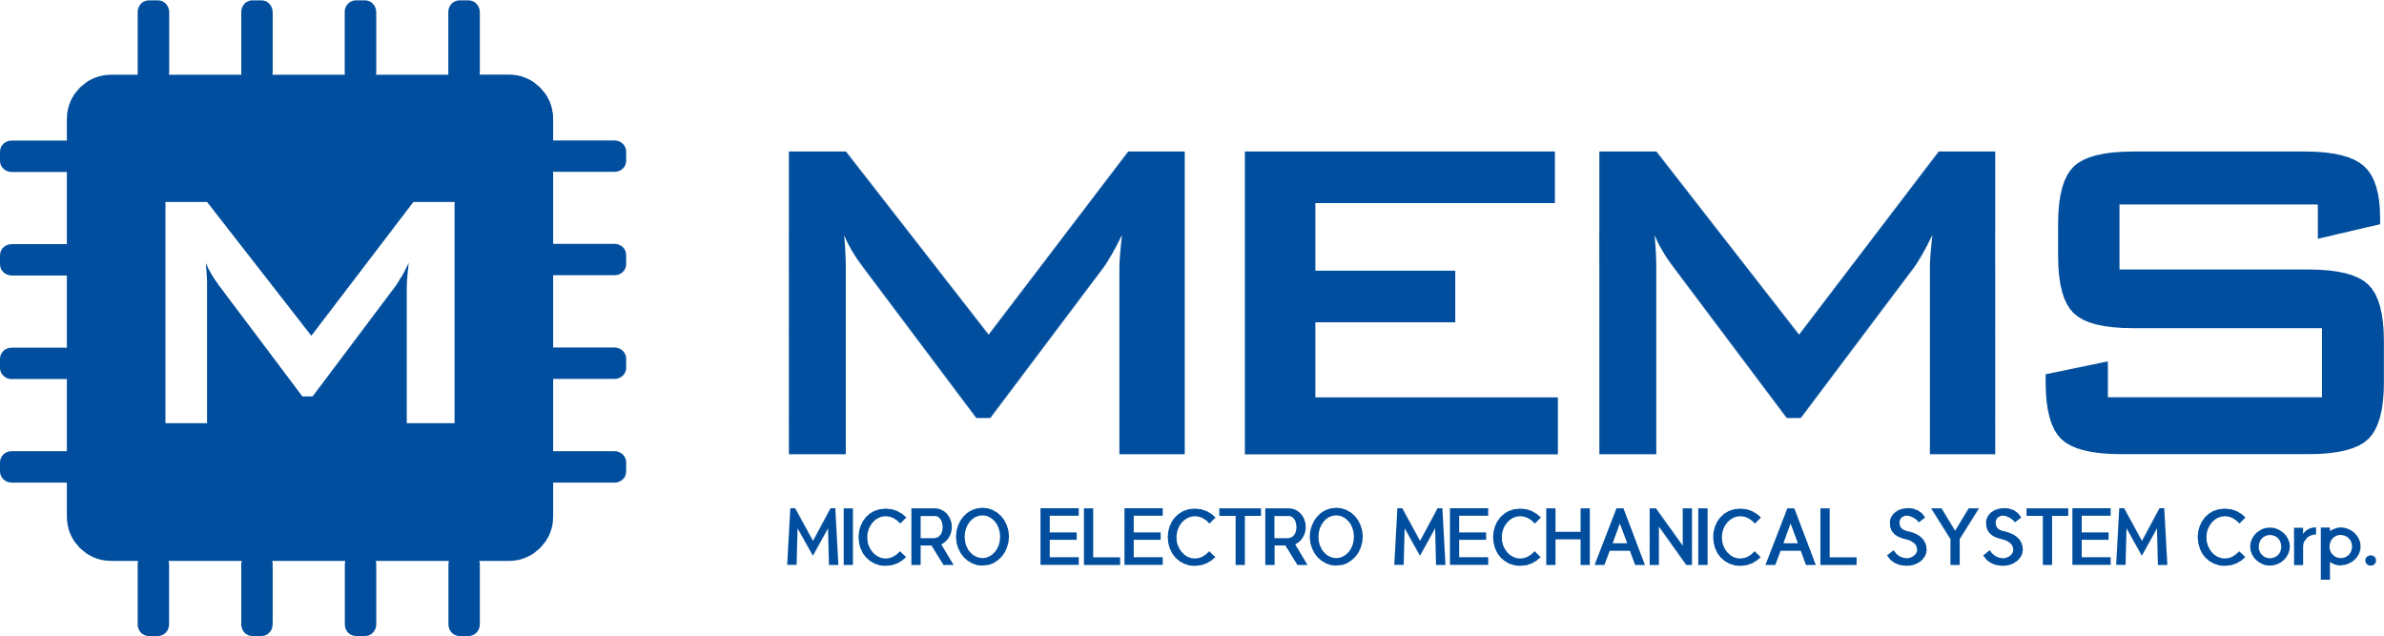    ※ SVG파일. 기타 형식 별첨.
President | Kim, Sei-Min
Website | https://koreamems.com
E-mail | mems@koreamems.com
Telephone | +82-62-710-6888
Fax | +82-62-710-6889
Exhibitor Introduction | MEMS Corp., established on January 12, 2021, specializes in semiconductor design, manufacturing, and simulation, demonstrating innovative technological capabilities in the semiconductor industry. We provide tailored foundry services and possess advanced expertise in MEMS-based production processes, enabling us to create diverse products customized for various sectors. Rather than focusing exclusively on a limited range of products, we continuously broaden our portfolio to meet the specific needs of multiple industries.  At MEMS Corp., we leverage MEMS technology to drive innovation across numerous sectors, offering solutions that enhance safety, health, and convenience. We actively collaborate with domestic and international partners to facilitate technological exchange, explore new markets, and develop solutions precisely tailored to customer requirements. Moving forward, MEMS Corp. remains committed to creating a better future through MEMS technology and achieving social value through technological advancement.
Exhibit Description | MEMS Corp. will present micro LED technologies for next-generation display applications at IMID 2026. Building on our expertise in semiconductor design, manufacturing, simulation, and MEMS-based processes, we provide integrated solutions for advanced display development.  Our exhibit will introduce key process capabilities related to micro LED chip design, fabrication, transfer, bonding, inspection, and module integration. We aim to support high-brightness, high-resolution, and high-reliability display solutions for diverse industrial applications, including AR, VR, automotive displays, wearable devices, and large-area display systems.  Through our tailored foundry services, MEMS Corp. provides flexible development support aligned with customer requirements. At IMID 2026, we seek to demonstrate the value of micro LED technology as a foundation for future display innovation and explore collaboration opportunities with domestic and international partners.
Exhibit Product | Micro-LED

